**DAILY ONLINE ACTIVITIES SUMMARY**

|  |  |  |  |  |  |  |  |  |
| --- | --- | --- | --- | --- | --- | --- | --- | --- |
| **Date:** | **10/07/2020** | | | | | **Name:** | **VIRESH** | |
| **Sem & Sec** | **4th SEM & ‘B’ SEC.** | | | | | **USN:** | **4AL18CS097** | |
| **Online Test Summary** | | | | | | | | |
| **Subject** | | **Object Oriented Concepts** | | | | | | |
| **Max. Marks** | | **30** | | **Score** | | | **-** | |
| **Certification Course Summary** | | | | | | | | |
| **Course** | **Introduction to Cyber Security** | | | | | | | |
| **Certificate Provider** | | | **Greatlearning Academy** | | **Duration** | | | **7.0 Hrs.** |
| **Coding Challenges** | | | | | | | | |
| **Problem Statement 1:** ----------- | | | | | | | | |
| **Status: ------** | | | | | | | | |
| **Uploaded the report in Github** | | | | | **Yes** | | | |
| **If yes Repository name** | | | | | **alvas-education-foundation/Viresh** | | | |
| **Uploaded the report in slack** | | | | | **Yes** | | | |

**Online Test Summary:** **Today 18CS45 Descriptive test was conducted, there were four questions and the test was from 09:30am to 10:15am. Test written in A4 sheets and uploaded in Google class room. Scores not received.**

**Online Certification Course Summary: Today I have attended the Quiz and successfully completed this Introduction to Cyber security certification course.**

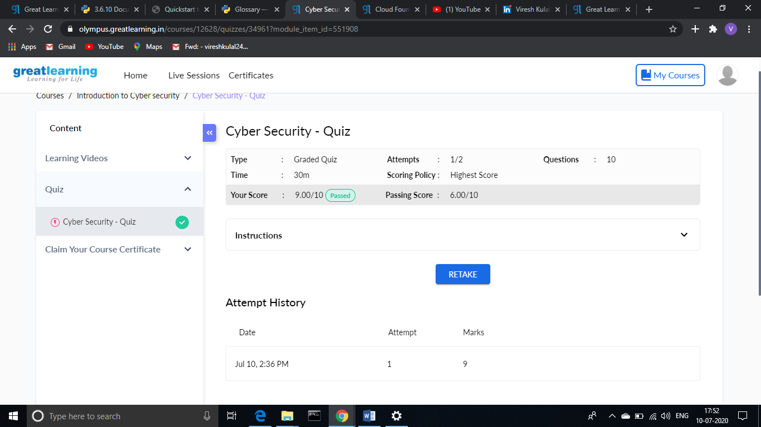

**This is the snapshot of quiz attended and marks obtained in the quiz.**

**This is the snapshot of course certificate I have completed.**

**Online Coding Summary: No problem statements are given.**

**Thank You.**